1. Development Steps:
- Home Screen Layout: I designed the Home Screen with a scrollable feed, integrating a ListHeaderComponent to allow the story bar and post feed to scroll seamlessly together.
- Post Item Component: I developed a reusable PostItem component to handle post rendering, including dynamic image loading and user-specific details.
- Interactive Features: I implemented Like/Unlike functionality with "Optimistic UI" updates, ensuring the app feels responsive by updating the UI instantly before the backend request finishes.
- Comments System: I built a dedicated CommentsScreen as a bottom sheet modal, allowing users to view and interact with comments without leaving the main feed.
- Persistent Data Handling: I refined the comments state management to ensure that newly posted comments remain visible on the screen and are properly synchronized with the backend.
- Backend Integration: I configured the backend routes to support comment creation and deletion, including Mongoose populate queries to fetch author details (username and profile picture) for every comment.
- Delete Functionality: I added a secure delete feature to the comments, restricted to the comment author, with a confirmation alert to prevent accidental deletions.
- UX Enhancements: I added keyboard handling via KeyboardAvoidingView to ensure the input field stays visible, and implemented hardcoded sample data for a more engaging initial user experience.
2. AI Interaction Record:
1:
I asked AI: How to use Stack and Tab navigation together in React Native?
AI gave code.
I integrated Stack and Tab navigation by setting the MainStack as the root parent, which allows full-screen modals like "Create Post" to overlay the BottomTabs navigator. This hierarchical structure ensures a smooth user experience by keeping the Tab bar accessible while managing separate navigation flows for specific screens.
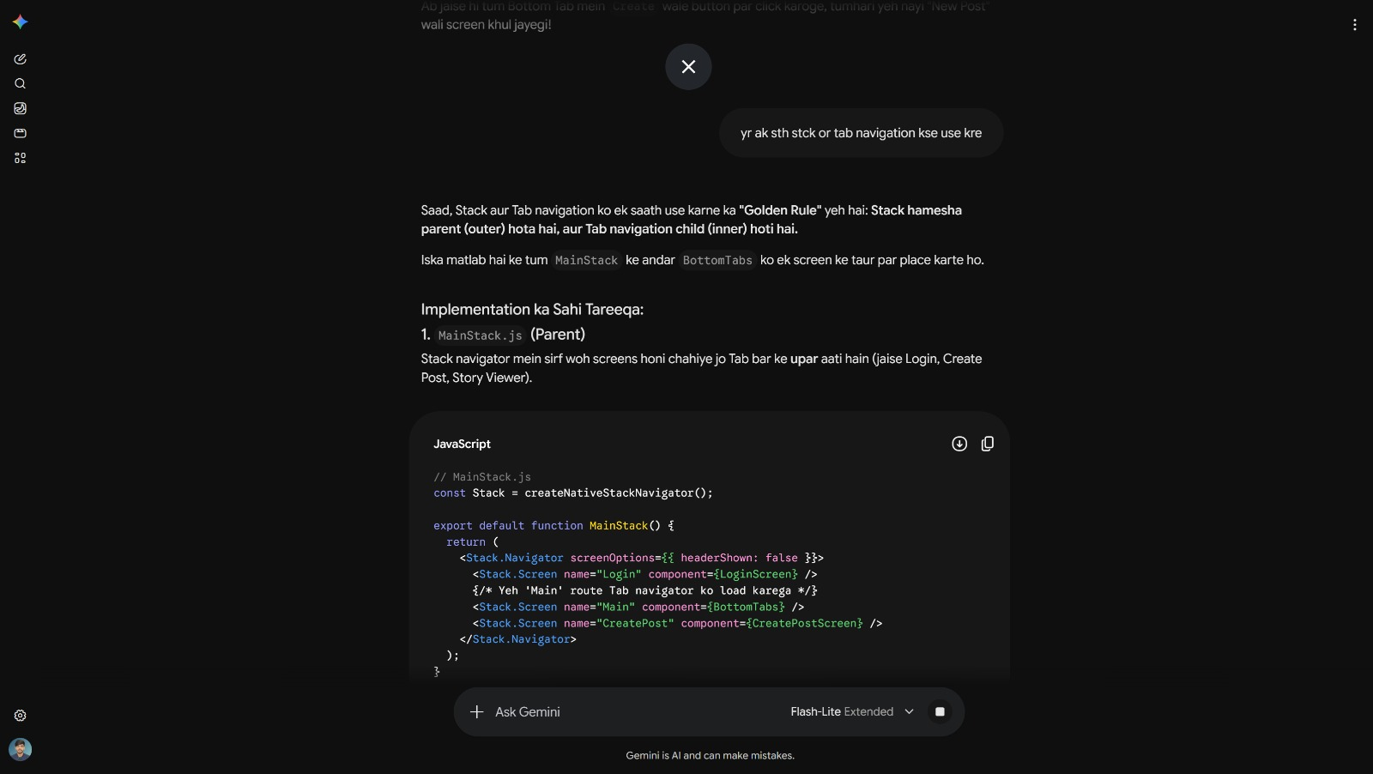
2:
I asked AI: How to fix the status bar/notch overlap issue in React Native?
AI gave code.
AI suggested: Replacing the default SafeAreaView from react-native with the more professional react-native-safe-area-context library. I implemented this by installing the library and updating my screen imports, which automatically adjusted the UI layout to respect device notch areas and status bars.

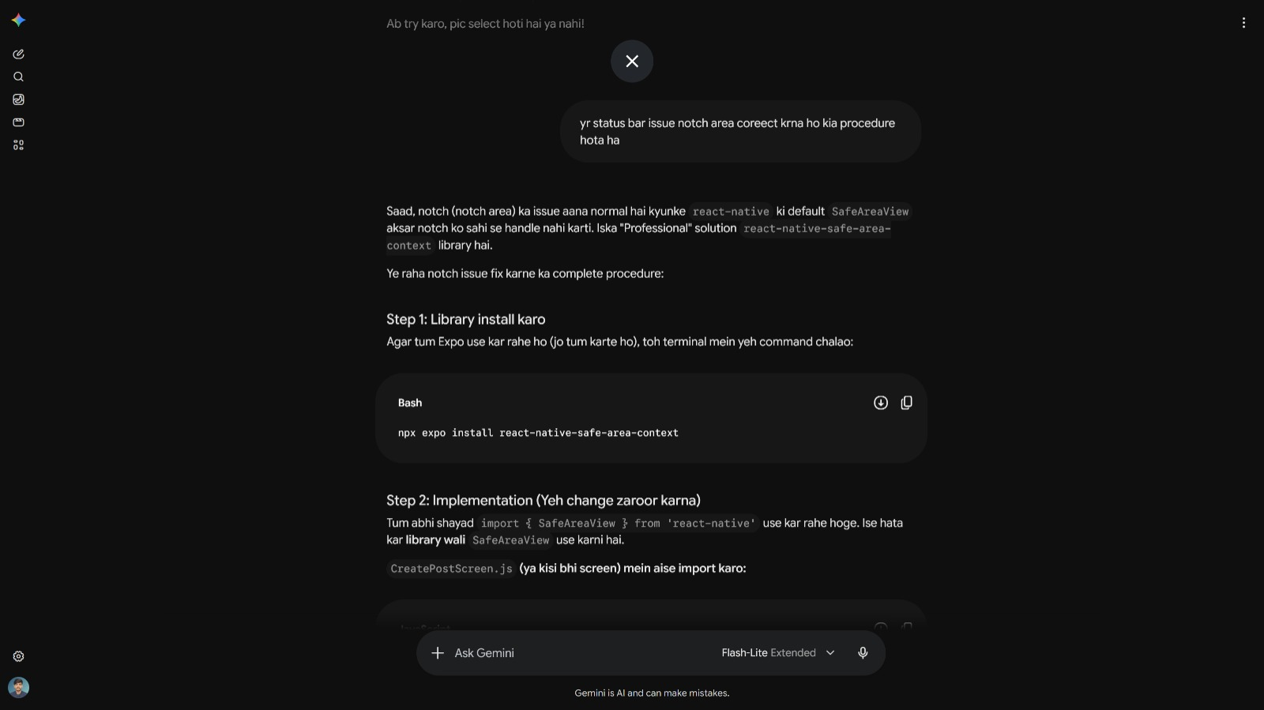

3:
I asked AI: How to connect the "Create Post" screen to the backend for image uploads?
AI gave code.
AI suggested: Using the FormData object on the frontend to handle multipart/form-data, paired with the multer middleware on the Express backend to process file uploads. I implemented this by creating a handlePublish function that appends post data to FormData, enabling successful image transmission to the server and storage in MongoDB.

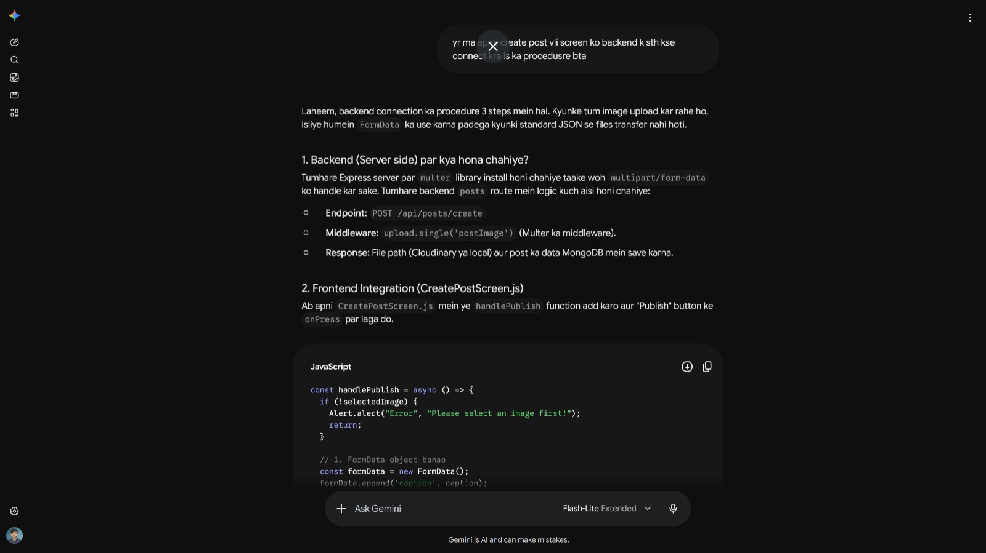

4:
I asked AI: How can I implement a double-tap to like feature in my post feed?
AI gave code.
AI suggested: Using a timestamp-based comparison to detect double-taps by tracking the time difference between consecutive clicks. I implemented this by maintaining a lastTap state and triggering the handleLike() function if a new click occurs within 300 milliseconds of the previous one.

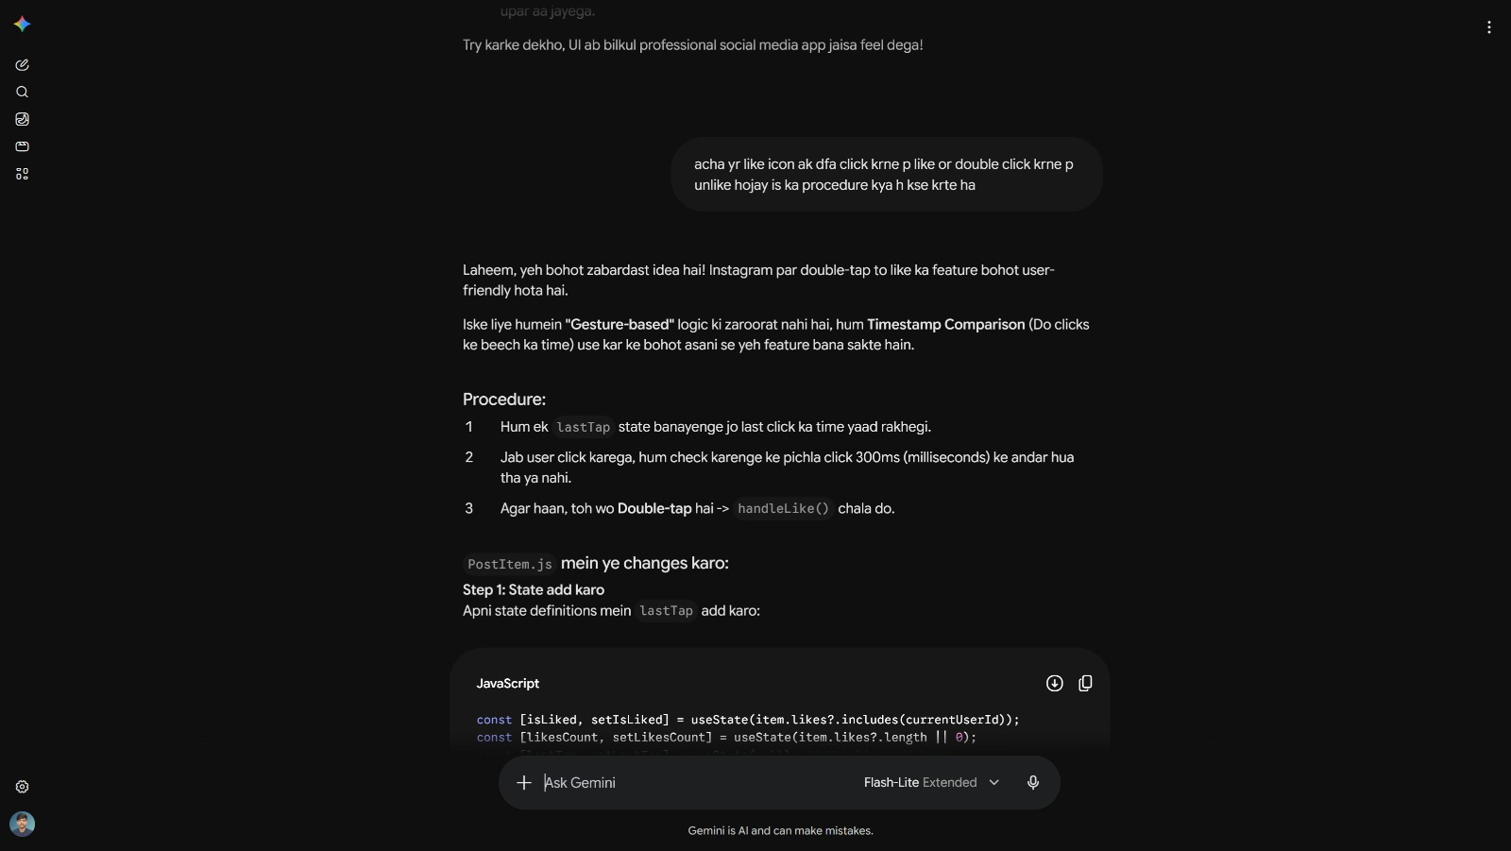

5:
I asked AI: How can I implement a "Reply" feature for comments in my application?
AI gave code.
AI suggested: Adopting a "Parent-Child" data structure where each comment includes a parentId field to track associations. I implemented this by updating the Comment model and adding a replyingTo state on the frontend, allowing users to seamlessly thread replies under specific comments.

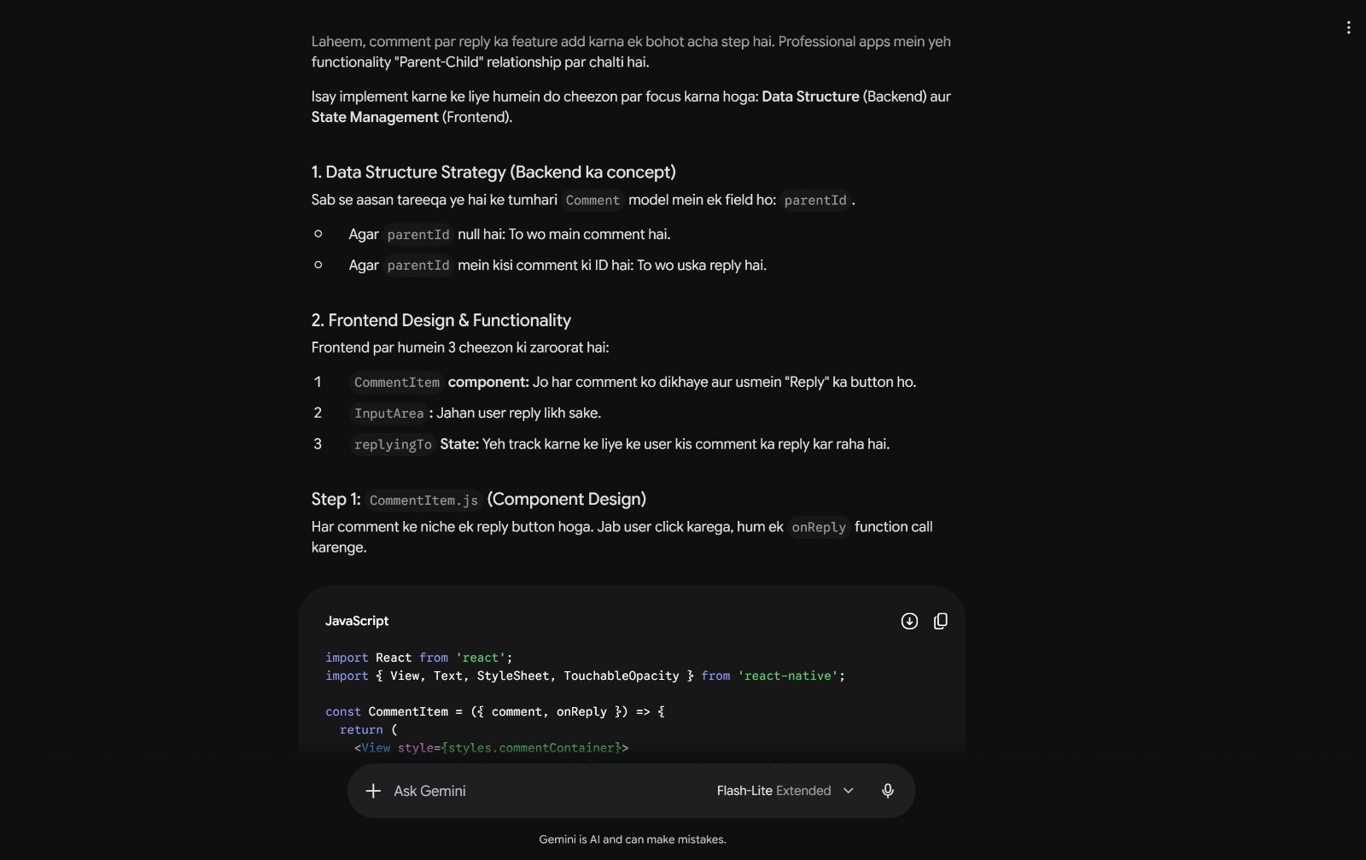

6:
I asked AI: How can I display the post author's username and profile picture on the post feed?
AI gave code.
AI suggested: Using the Mongoose .populate('author') method on the backend to embed the complete author object within each post. I implemented this by accessing the item.author.username and item.author.profilePic properties on the frontend, allowing for dynamic user information rendering on each post.

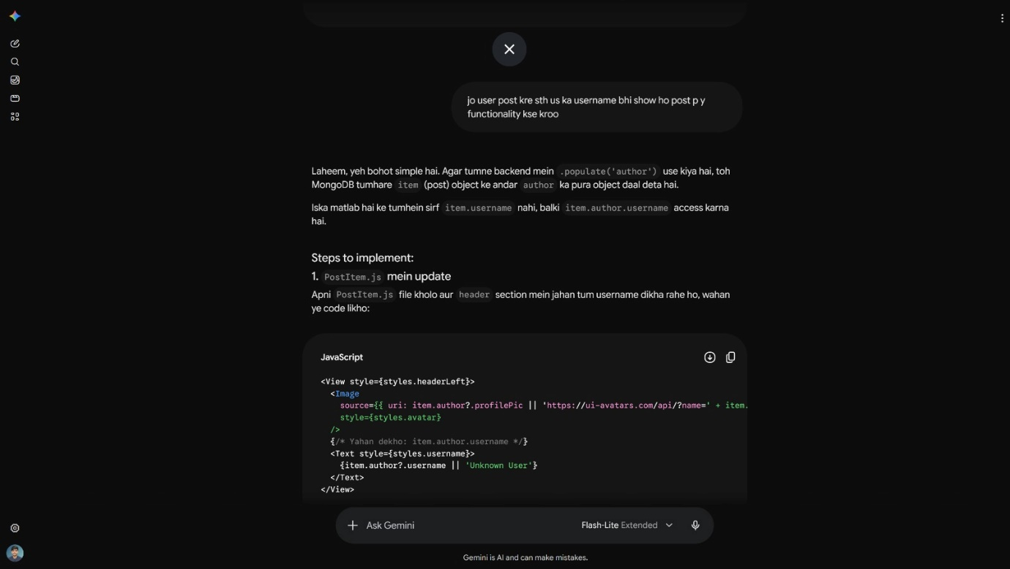

7:
I asked AI: How can I publish a new post from the "Create Post" screen and ensure the home feed updates automatically?
AI gave code.
AI suggested: Using FormData to send the post data and image to the backend for storage, while utilizing useFocusEffect on the HomeScreen to automatically trigger a feed refresh whenever the user navigates back. I implemented this by creating a handlePublish function and setting up a re-fetch logic, ensuring seamless post updates across the application.

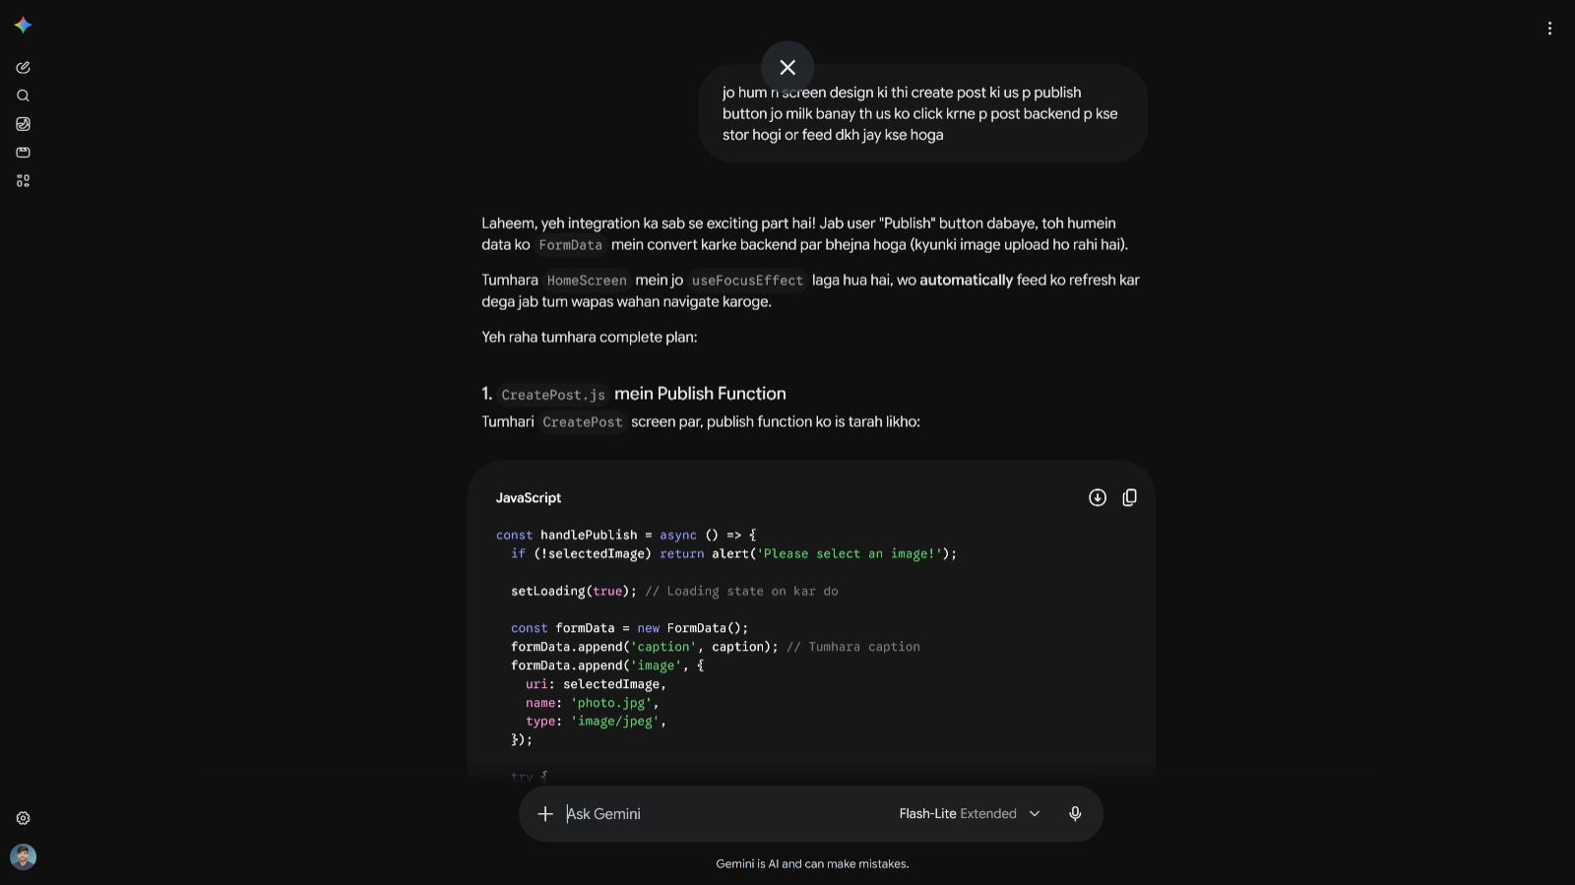

8:
I asked AI: How can I trigger the comment screen as a bottom sheet drawer when clicking the comment icon?
AI gave code.
AI suggested: Using the React Navigation presentation: 'modal' option within the Stack.Navigator configuration. I implemented this by registering the CommentsScreen as a modal in my navigation stack and triggering navigation.navigate('Comments') within the PostItem component, which creates a smooth bottom-sheet transition.

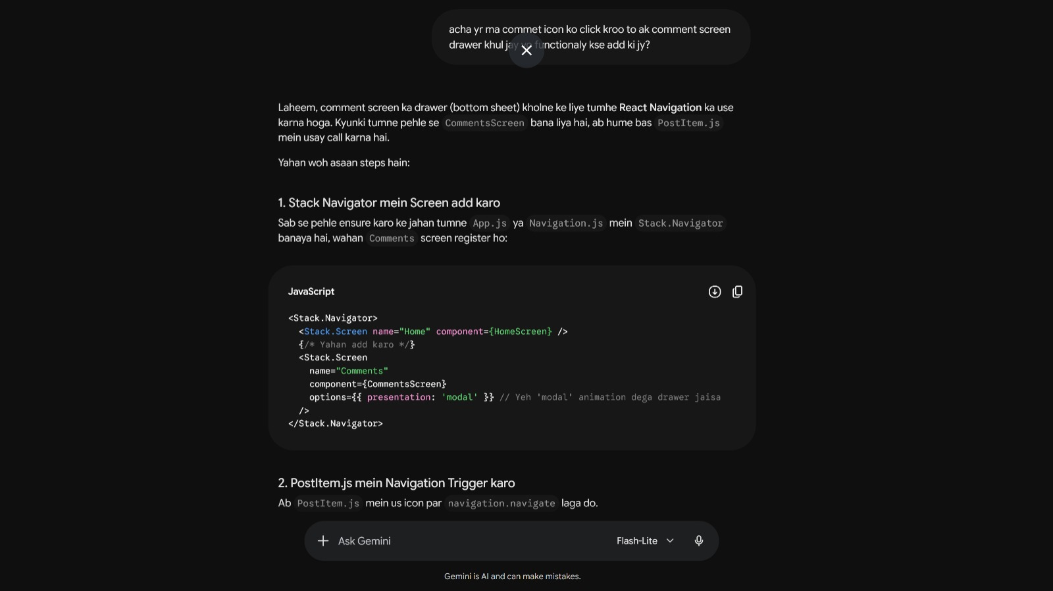

3. Problems Faced
- Navigation Complexity: Integrating Stack and Tab navigation together caused issues with full-screen modals overlaying the bottom tab bar.
- Notch Overlap: The status bar and notch area on mobile devices were incorrectly covering parts of the UI using the default SafeAreaView.
- Backend Image Uploads: Connecting the "Create Post" screen to the backend initially failed because standard JSON cannot transmit file data.
- Like Interaction Logic: Creating a professional, gesture-based "double-tap to like" experience without using complex gesture libraries was tricky.
- Comment Threading: Implementing a reply system required managing hierarchical parent-child relationships in both the data structure and the frontend UI.
- Dynamic Data Rendering: Displaying specific user details (username/profile picture) on posts required mapping the populated author object correctly.
4. Solutions
- Navigation Structure: I implemented a hierarchical structure where MainStack acts as the root, allowing full-screen modals to correctly overlay the BottomTabs navigator.
- UI Layout: I replaced the default SafeAreaView with react-native-safe-area-context to automatically adjust the layout for device notches and status bars.
- API Integration: I used FormData on the frontend to handle multipart/form-data and implemented multer middleware on the backend to process image uploads.
- Double-Tap Logic: I implemented a timestamp-based comparison using lastTap state to track clicks, triggering the like function only if a new tap occurs within 300ms.
- Comment Threading: I updated the Comment model to include a parentId field and managed reply states on the frontend to thread conversations effectively.
- Data Mapping: I utilized Mongoose .populate('author') to embed the full author object in posts, allowing me to dynamically render the correct username and profile image for every post.
5. Learning Reflection
What I Learned: This project taught me how to architect professional navigation, handle complex asynchronous data (like multi-part image uploads), and manage component states for interactive features. I gained solid experience in backend-frontend data mapping and building user-centric UI components that feel responsive and professional.
What was difficult: The most challenging part was managing the navigation flow between Stack and Tab navigators while ensuring that interactive features like comment replies and double-tap likes functioned smoothly. Troubleshooting the UI layout for different screen notches and handling the asynchronous nature of API requests for file uploads also required significant debugging and iterative testing.

